Go To
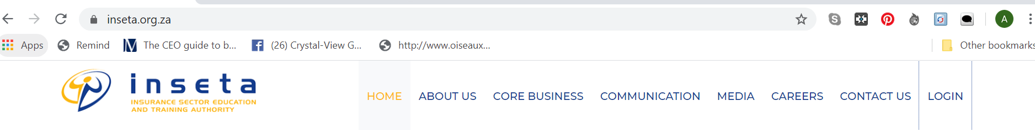

Then type in your Username and Password

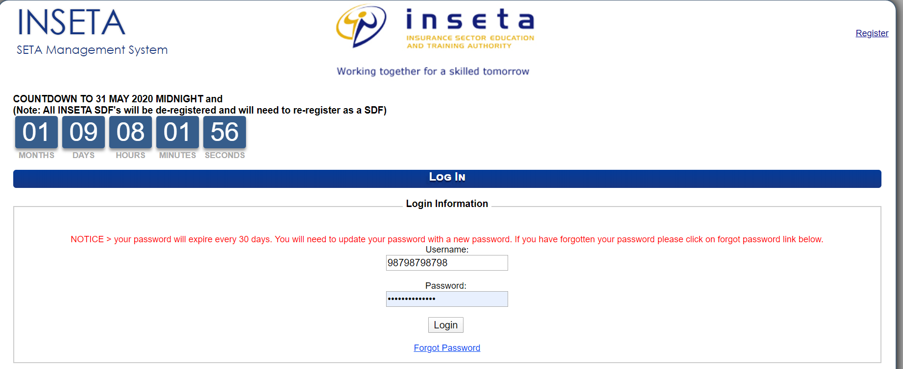
Select your user profile and SEARCH profile
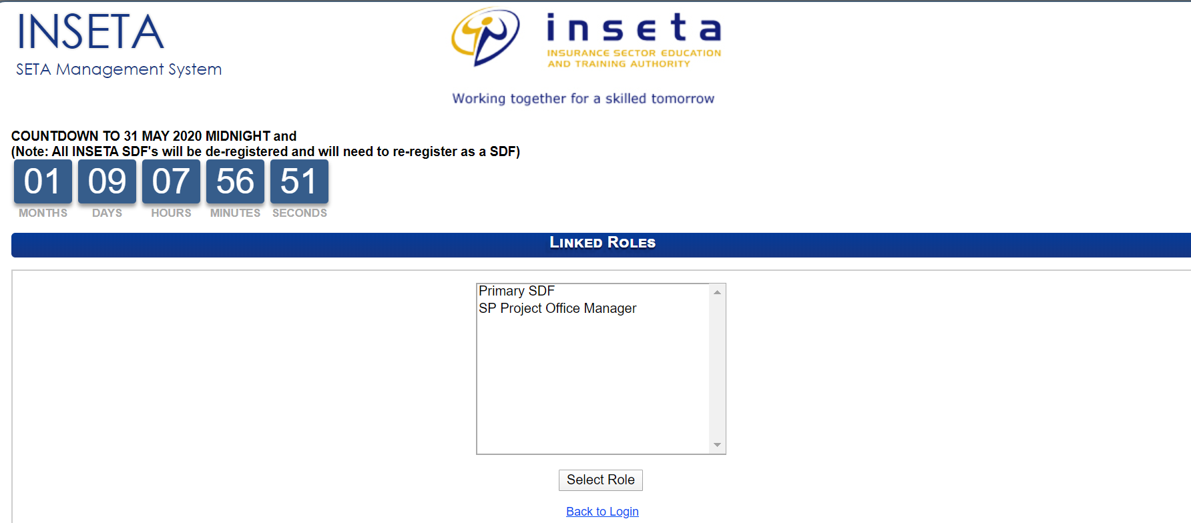

On the next landing page - Click on DG at the top Heading
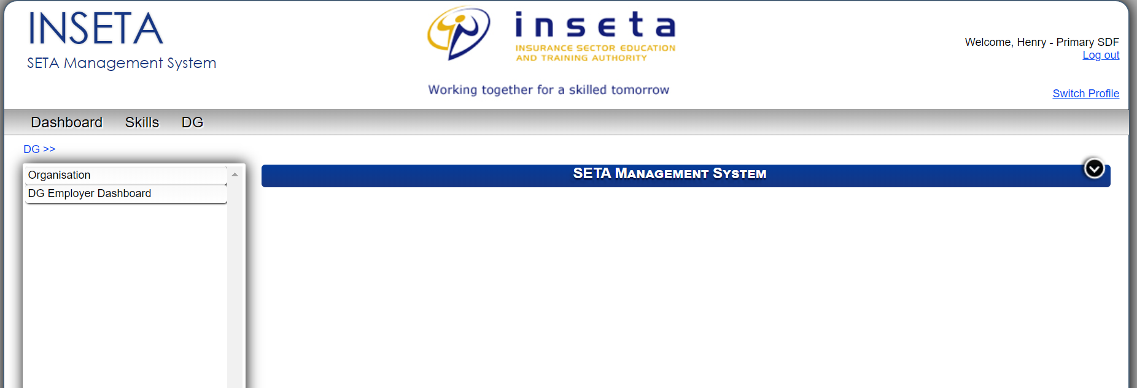

Click on Organisation – Then type in the organisation name and search. Then Highlight the organisation name and click the search function again under the Action bar

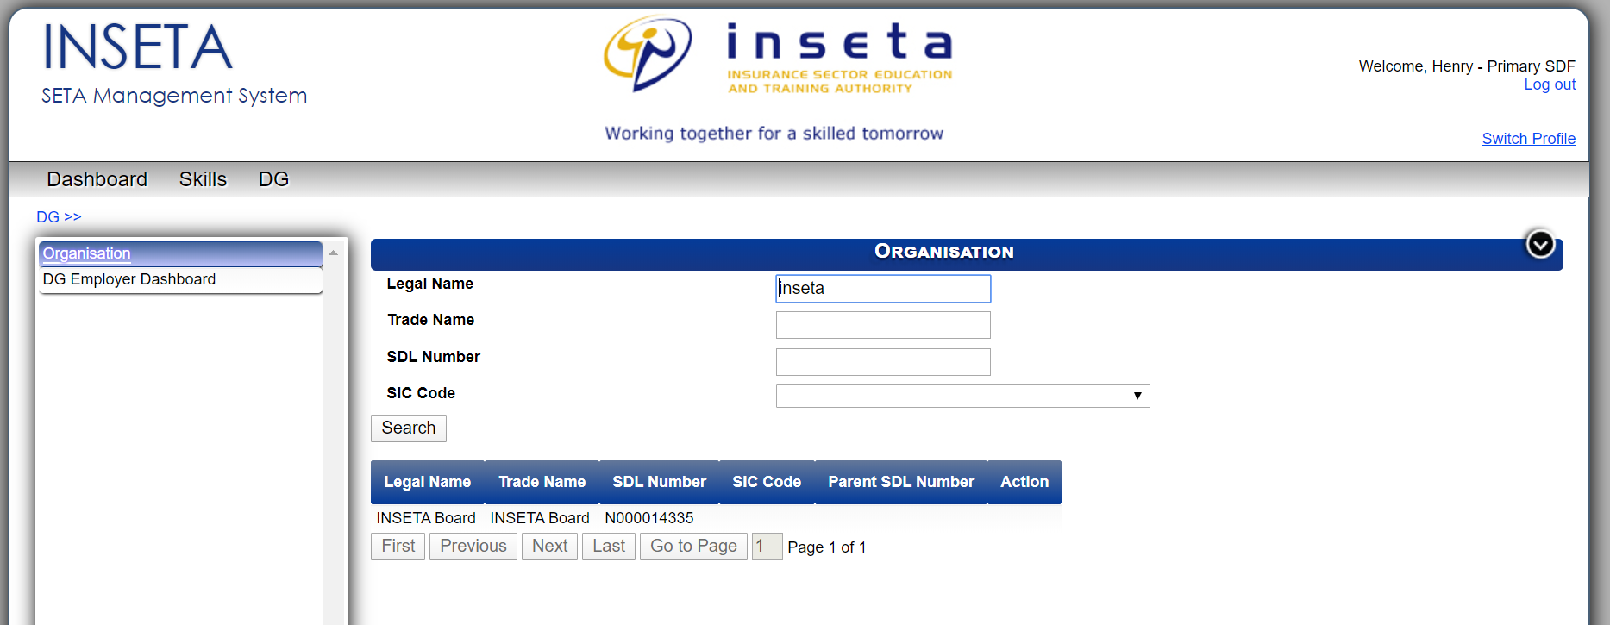

After you get to the next screen – make sure you have the correct financial year 2020 – 2021 and then click the dropdown box next to that for the type of funding you wish to access. Then click CREATE

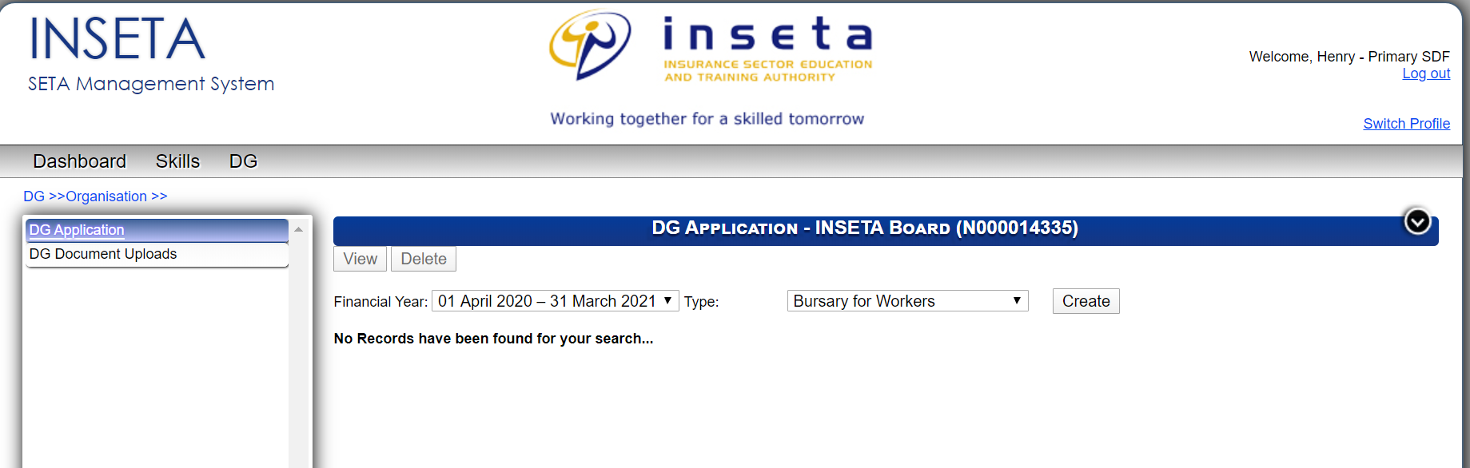

After the application form has been created – highlight the form and click on VIEW on the top left hand corner to open the form and complete the information.
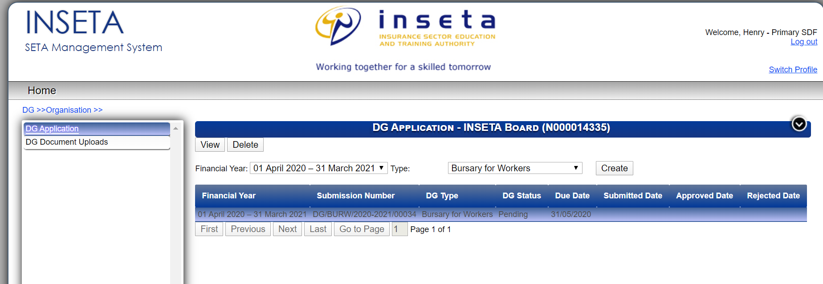

The form consists of three sections and is straight forward. Make sure that the programs you select for your learners are linked to the scarce and critical skills list which can be found on
www.inseta.org.za Go to CORE BUSINESS then SKILLS and the scarce and critical skills list is on this page at the bottom.
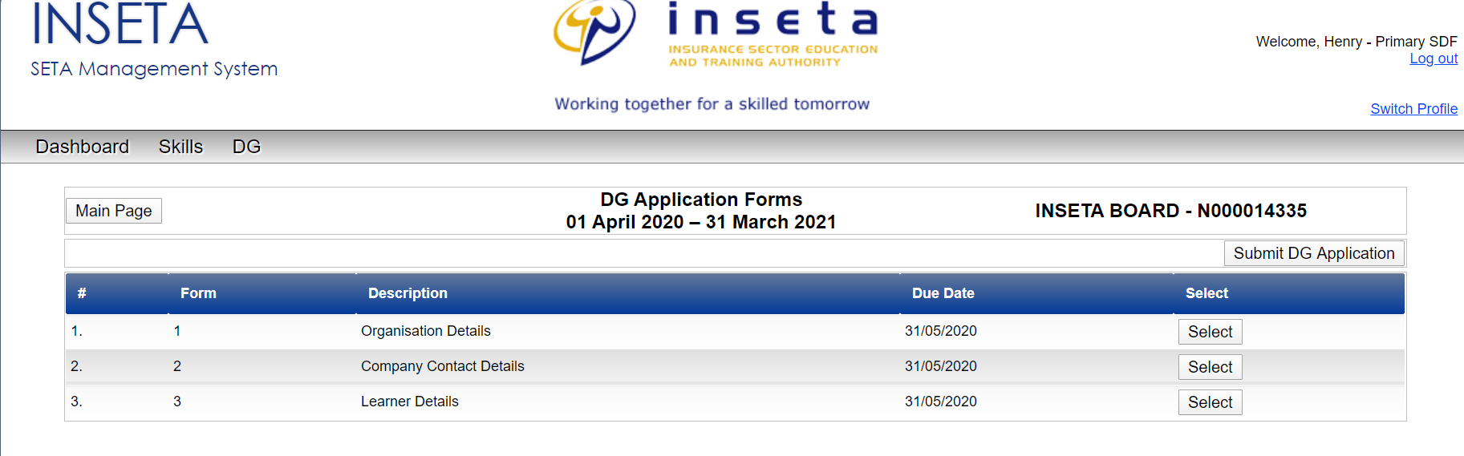

Organisation Details and Company contact details are straight forward so I will go straight to Learner details
- Ensure that you have all information on hand before going into the system.
- Type in number of learners to be trained
- Type in if the learners will be training through a PUBLIC or PRIVATE provider
- The last three fields are compulsory which is funding amount, Duration and Qualification Title so ensure that you liaise with your training provider before you type in the name of the Qualification.
- Once completed, click on ADD
- Should you have a long list of learners to add to the system then you can complete the Bulk upload form
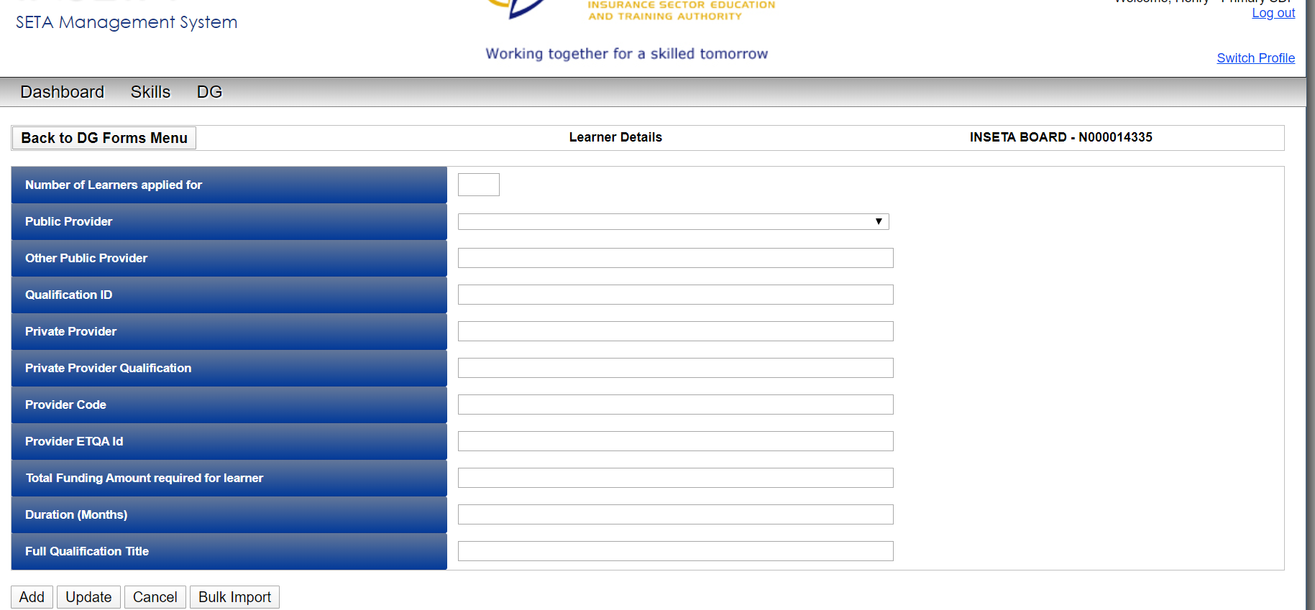

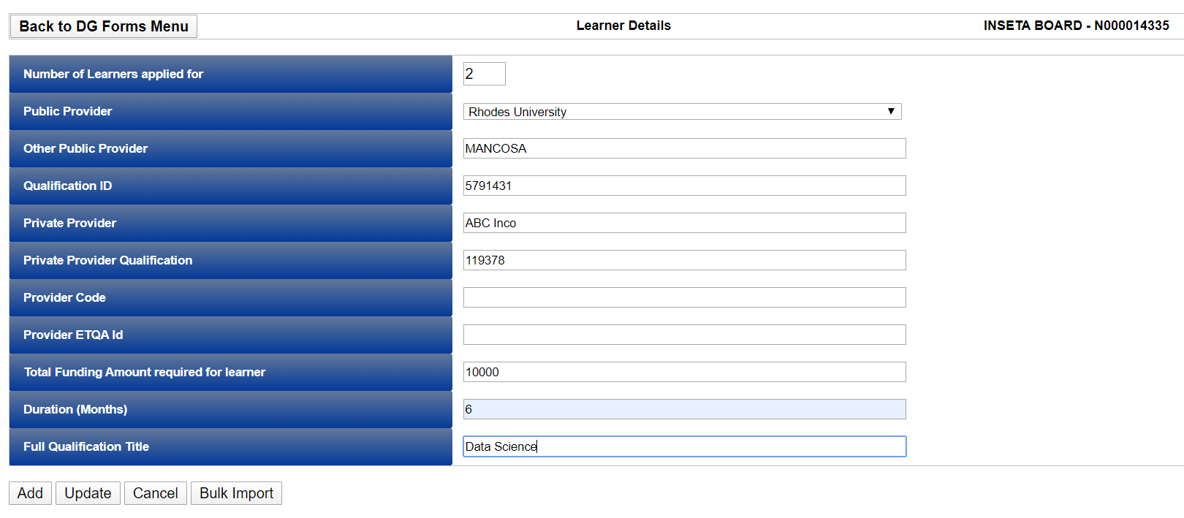

Information is then added after clicking the ADD button
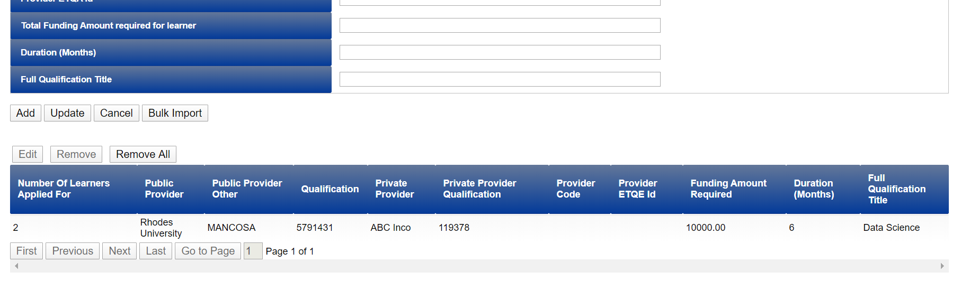
To Go BACK to the main menu – click on BACK to DG forms Menu on the top left
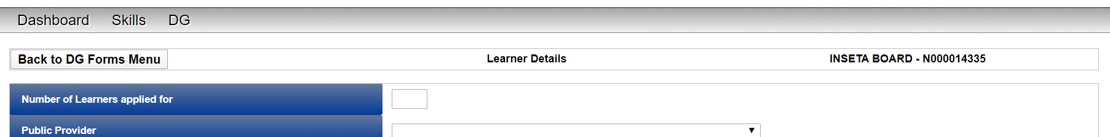

To Submit click on SUMIT DG Application on the top right hand corner

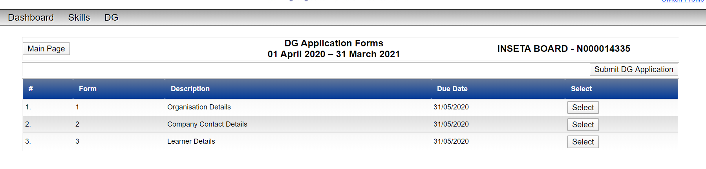

This message will appear – click OK and your status will change from submit to Submitted application.

