INSETA LEARNER RECORD DATABASE (Indicium)
USER GUIDE

Version 4 2018

Table of Contents
Section 1: Introduction Error! Bookmark not defined.
1. Purpose of the INSETA Learner Management System 3
2. Principles of Error! Bookmark not defined.
3. Roles and Responsibilities of Skill Development Providers 3
Section 2: Logging onto Indicium 4
1. System Requirements 4
2. Webmail Address 4
3. Rules and Security of Access 4
4. Steps to Log-on 4
Section 3: Menu Overview 6
Section 4: Enrolling Learners onto the LMS 7
1. The Learner Menu 7
2. No Records found for your Search 8
Updating or Editing Person (Learner) Data 14
Specifications for Capturing Person / Learner Information 15
Capturing the Person as a Learner. 17
Programme Enrolment / Registration: Linking a learner to a qualification / skills programme. 19
Capturing Assessments against a learner: 21
Section 5: Provider Details 25

Section 1: Introduction

Purpose of the INSETA Learner Management System
  - The INSETA Learner Management system (Indicium) is a repository that stores and maintains records of:
    - Learners: their personal details, their enrolments and their achievements;
    - Details and profiles of accredited skill development providers (SDPs) and associated qualification scope;
    - Profiles of registered assessors and moderators and the qualifications they are allowed to assess/moderate
    - Details of employers.

  - The records are maintained by skill development providers and the INSETA QAP/ETQA.
  - INSETA transmits these records bi-annually to SAQA to be loaded into the NLRD, and to the Department of Higher Education and Training’s SETMIS on a quarterly basis.
Thus, Skill Development Provider compliance to INSETA deadlines and data specifications is of the utmost importance.

Roles and Responsibilities of Skill Development Providers
Skill Development Providers’ responsibilities include:
  - Capture/Upload learner enrolments onto the INSETA Learner Record Database within 7 working days of the learners commencing their studies.
  - Capture/Upload learner achievements onto the INSETA Learner Management System within 21 working days after receipt of a signed endorsed Verification NLRD from INSETA Verifier
  - Ensure that Administrators employed by the Skills Development Provider attend training on the INSETA Learner Management System
  - Take full accountability for the records captured on the Learner Management System, by conducting regular quality assurance of such records
  - Ensure learner information is captured in accordance with the INSETA Learner Record Specifications

Section 2: Logging onto Indicium
- System Requirements
INDICIUM is best using Google Chrome or Firefox.
- Webmail Address
http://indicium.inseta.org.za/Account/Login.aspx
- Rules of User Access
  - Access to Indicium is restricted to users by means of a Username and Password. In order to obtain access, the Provider must complete, sign and email to the Certification unit the Access Request Form. A Username and Password will then be emailed to you.
  - Your Password will expire after 30 days. On expiry, the Indicium system will prompt you to change your password at the point you try to login.
  - Usernames and Passwords are a security feature to safeguard the data contained on Indicium. It is thus critically important that users do not share their Usernames and Passwords with others. The system records all user access and activity thus enabling INSETA to identify who entered data, what data they entered and the time they entered it.
- How to Log on
Step 1: Go the website www.inseta.org.za
Step 2: On the Left hand Side of the INSETA Home Page, Click on log in
The below screen will appear.
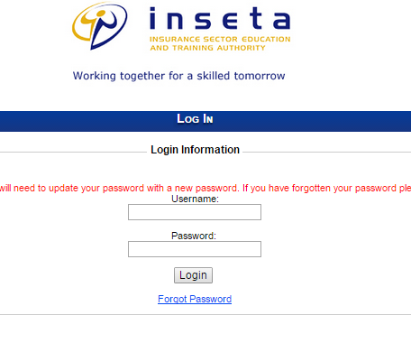
Step 3: Enter your Username and Password (Both supplied to you by INSETA)
Step 4: Click on the Login button

Once you have logged in the following screen will appear:

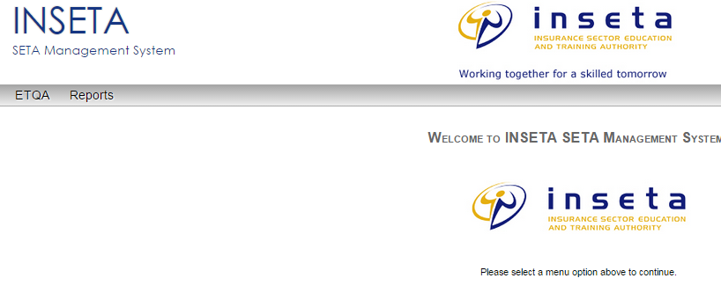
Section 3 describes these menus.

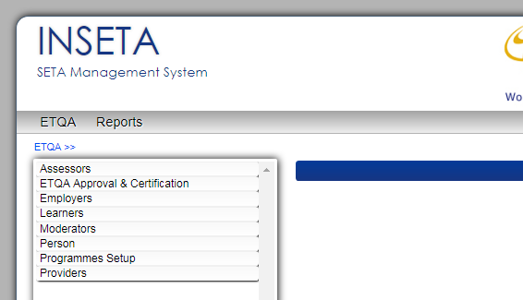
Section 3: Menu Overview
Assessors Menu
Details of your Assessors
Learners Menu
To search for an existing Learner or/and Create a new Learner.
Employers Menu
Details of your learners’ employers
ETQA Approval & Certification Menu
To download learners’ INSETA Statements of Results
Moderators Menu
Details of your Moderators
Clicking on “ETQA” will bring up the Main Menu.
Programme Setup Menu
To set-up a Skills Programme / Qualification Modules. This menu is not active for Providers
Person Menu
To enrol a learner who does not already exist on the database.
Downloads a Report of all learners & their details enrolled with you
Providers Menu
Contains details of the Skills Development Provider

Section 4: Enrolling Learners onto the LMS
- Checking if the Learner exists on the LMS
  - Click on Menu ETQA
  - Click on Learners
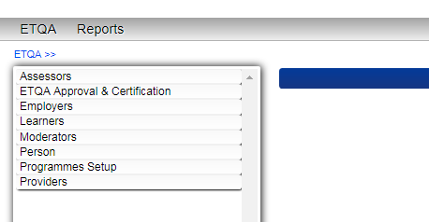
  - Type in the Learner’s ID number or Passport number
  - Click on Search
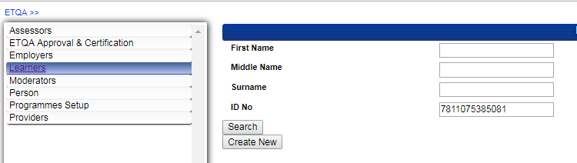
  - Once you have clicked on the Search button, you will see either:
    - The learner record appears
OR
    - The message “No Records have been found for your search…” appears

Learner Record appears:
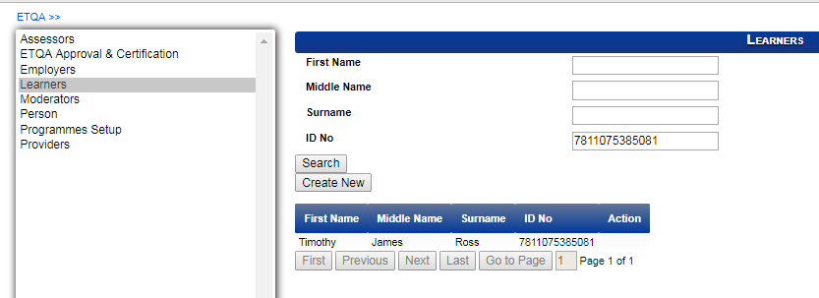
OR
The message “No Records have been found for your search…”
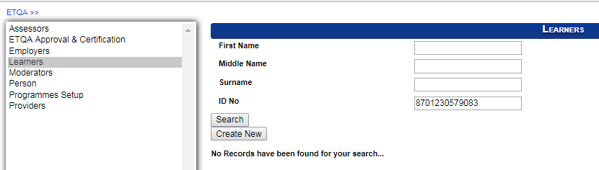
- No Learner Record found for your Search

  - Click on Person
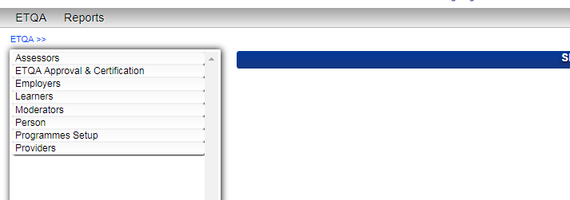

The following screen will appear:
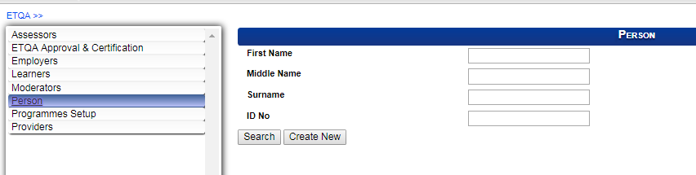
  - Type in the learner’s ID number or Alternative ID number (Passport number)
  - Click on Create New
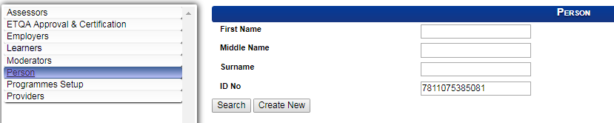

The following screen will appear

Note the Title of this screen is “Person Details”

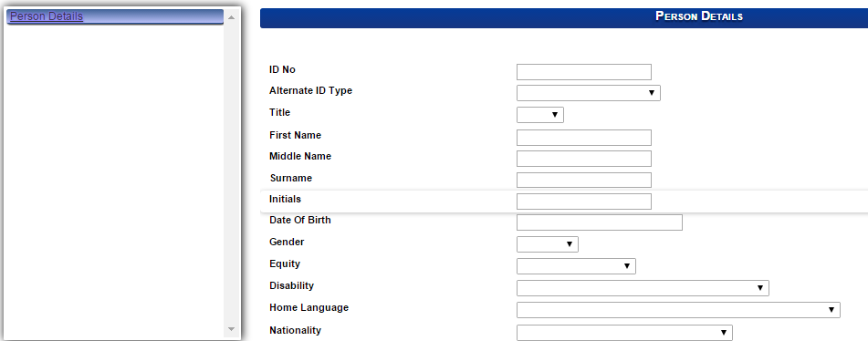
  - Capture all the fields on this screen, according to the INSETA Specifications Manual.
- The Learner Record Exists on the LMS
  - Highlight the Learner by clicking on the Learner’s Name / Surname / ID. 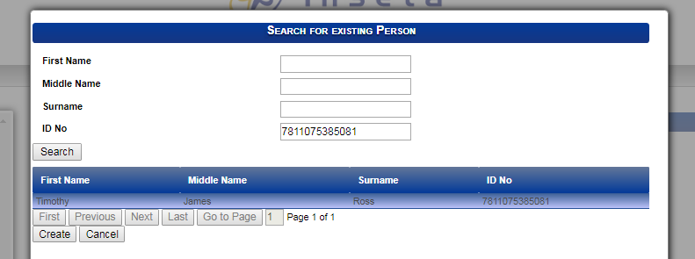

The following screen will appear, showing the learner details which were previously captured by another Skills development Provider.

Please note the change of Menu.

These menus refer to the
Particular learner and his/her
enrolments, achievements, etc

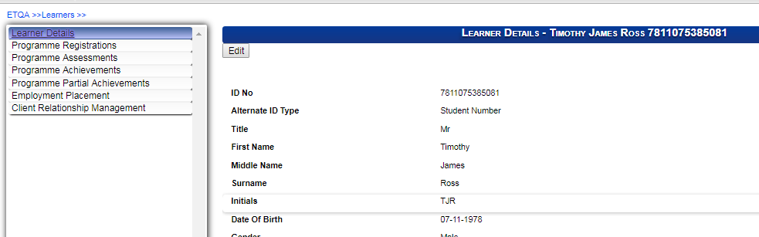

Click on Edit and update the learner’s information according to the information on his/her enrolment form.
All updating / editing or capturing of this information must be in accordance with the INSETA Specifications Manual

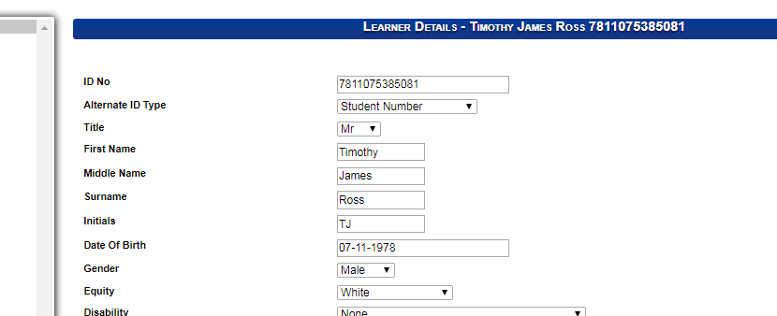

Once the learners record is correct, and complete, click on Save.
You will find the Save button at the bottom of the page.
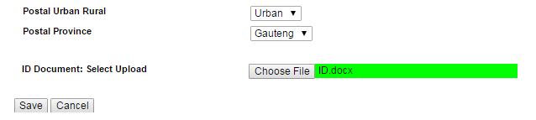

- Upload the Learner ID (Certified Copy). If an ID is not uploaded, providers will not be able to enrol a learner.

- Click on the Save button to save the information.

Updating or Editing Person (Learner) Data
Click on the Edit button at the top the learner/person record. Make changes. Click on Save button once all changes are done.
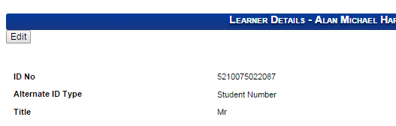

Specifications for Capturing Person / Learner Information
Field | Specifications | Illustration
ID Number | No spaces are allowed between numbers and or letters. | Options:  - South African ID number  - Birth Certificate Number (SA or foreign)  - Passport Number (Foreign only)
Alternative ID Type | SA ID Number | Blank
 | Birth Certificate Number | “Birth Certificate”
 | Passport Number | “Passport Number”
Title | Select from the drop-down
First Name | Enter only 1 name.  No Capital Letters are allowed, except for the first letter.  Hyphens are allowed | - Mark  M = Capital letter  ark = Lower case only  X MARK  - Lee-Ann
Middle Name | May enter 1 or more names.  If two or more names are entered as “middle Names”, leave a space between the names. | - Mark David  X MARK DAVID  Mark (space) David  - Mark David  X MarkDavid
Surname | No Capital Letters are allowed, except for the first letter.  Hyphens are allowed. | - Dlamini  X DLAMINI  - Lee-Ann
Initials | This field will automatically populate
Date of Birth | This field will automatically populate if entered a SA ID number.  If the ID number is a non-SA or a passport number, the provider must capture this field.
Gender | Male / Female  Will automatically populate if entered a SA ID number.  If the ID number is a non-SA or a passport number, the provider must capture this field.
Equity (race) | Select from the drop-down list
Disability | Select from the drop-down list.
Home Language | Select from the drop-down list
Nationality | Select from the drop-down list
Citizen Residential Status | Select from the drop-down list | Dual = is a resident of SA and another country  Permanent Resident = born in another country (not SA) but SA government has granted the individual permanent residence.
Telephone Number | Not compulsory.  No spaces are allowed between numbers.
Cell | COMPULSORY  No spaces are allowed between numbers | If learner does not have a cell phone number, enter telephone (land line) number under this field.
Fax | Not compulsory
Email | COMPULSORY | An email address is required for a learner to re-set his/her Indicium Password.
Physical Code (Address) | Please ensure this code is correct.
Physical Address 1 | 54 Duncan Village | 34 Field Road
Physical Address 2 | 16 Peter Road | Orange Grove
Physical Address 3 | Sandown | Orange Grove
Physical Municipality | This will automatically populate when the Physical Code is entered
Physical Urban Rural | This will automatically populate when the Physical Code is entered
Physical Province | This will automatically populate when the Physical Code is entered
Use Physical Address for Postal Address | If this box is ticked the Postal Adddress fields will automatically populate
 | If the box is not ticked, complete the Postal Address Fields
Postal Code | Please ensure the Postal Code is correct
Postal Address 1 | PO Box 54
Postal Address 2 | Eesterus
Postal Address 3 | Eesterus
Postal Municipality | This will automatically populate when the Postal Code field is completed
Postal Urban Rural | This will automatically populate when the Postal Code field is completed
Postal Province | This will automatically populate when the Postal Code field is completed

Capturing the Person as a Learner.
Click on Learners on the ETQA Menu
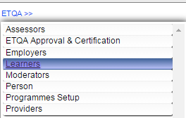
The following screen will appear:
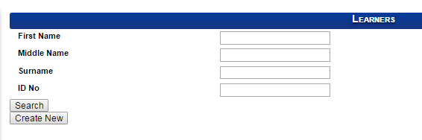
Add the Search criteria and click on Create New
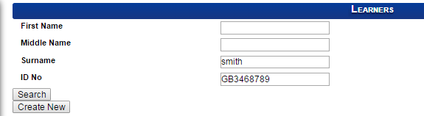
The individual will appear.. Click on the individual to highlight it. Click on “Create”
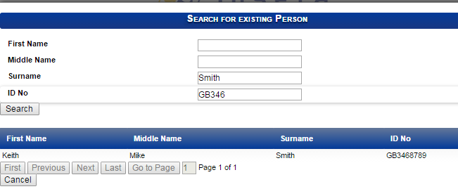
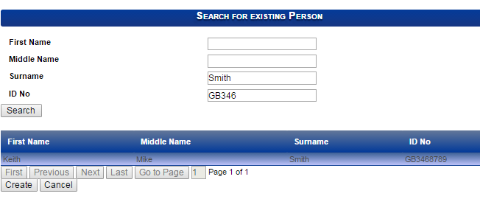

The menu on the left hand side will change, giving the sub menus for the learner.
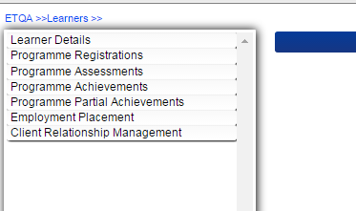
You can now view all the credits the learner has achieved, by clicking on any or all of the menus

Programme Enrolment / Registration: Linking a learner to a qualification / skills programme.
Click on Programme Registrations.
Select and Click on the learning programme type (qualification, skills programme, learnership or individual unit standards)
[If no ID document has been loaded for the learner, you will not be able to enrol the learner on a learning programme. Upload the ID .
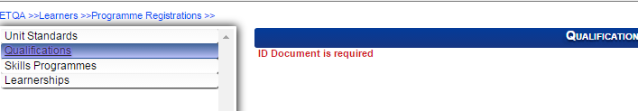

Click on Add Qualifications
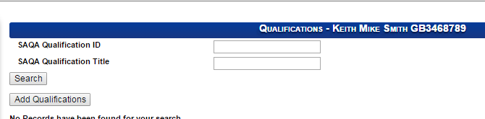

Enter the information on the new screen that appears (see below)
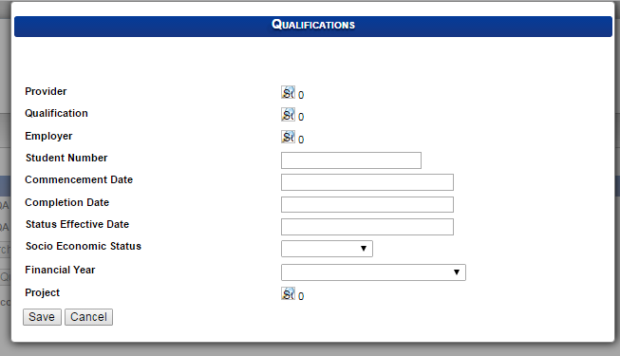
NOTES:
- Completion Date: The date the learner will complete the programme with the provider (irrespective of whether s/he has achieved or not achieved the learning programme).
- The Completion Date is the Date on which the learner wrote the Summative Assessment.
- If Socio Economic Status is selected as Employed, the Employer information must be entered.
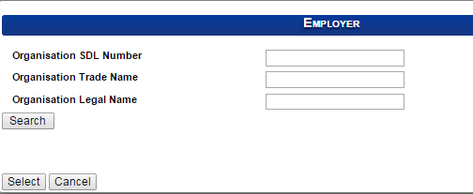
Click on Save to save the information

Capturing Assessments against a learner:
ETQA >> Learners >>[enter learner details & click on Search] >>Select the learner by highlighting him/her >> Click on the magnifying glass to open the Learner Menu >> Click on Programme Assessments.

Click on the learning programme type you wish to capture assessments against.
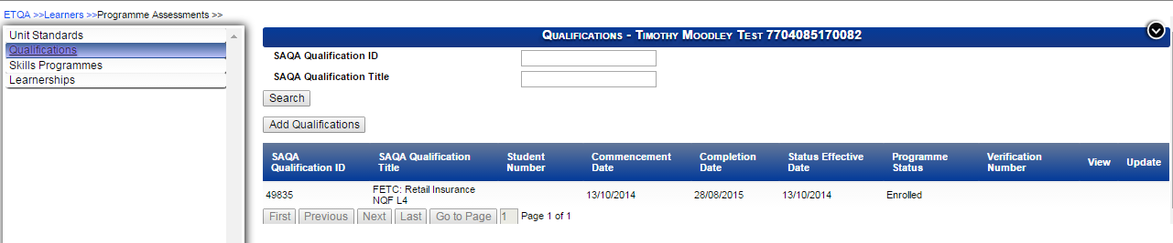
Highlight the record
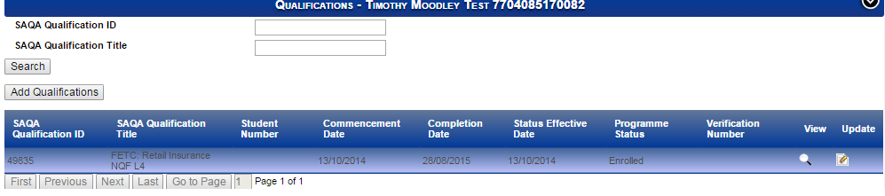
Click on the Update icon to capture or edit assessments.
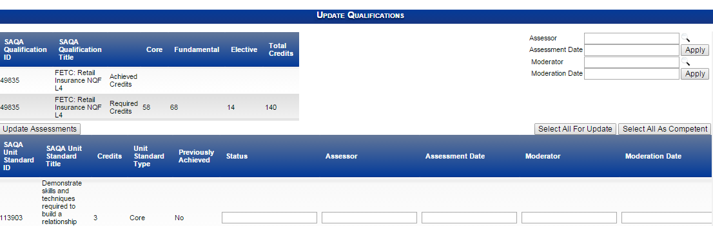

Click on the magnifying glass next to Assessor.
The following screen appears:
Click on Search to get a list of all assessors registered against the provider.
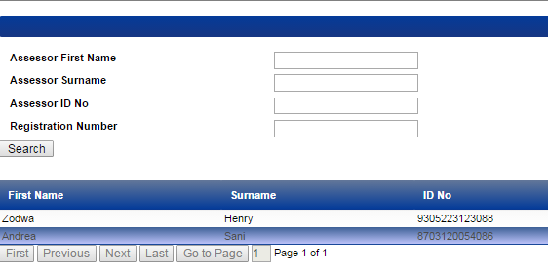
Highlight the assessor.
Click Select
The assessor field will populate
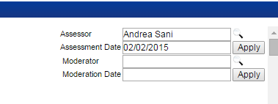
Enter the date that the assessment took place.
Follow the same process above for the moderator.
Selecting the unit standards which were assessed.
- Only select the unit standards that the learner was found competent for.

Select the boxes Update and Competent.
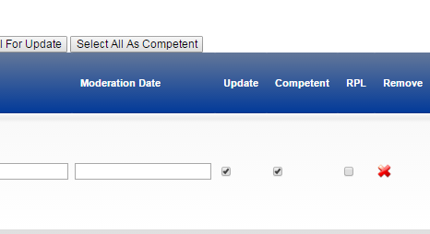

Click on Apply. The assessor name and assessment date will appear against the unit standard.
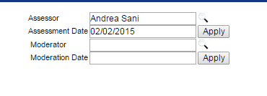

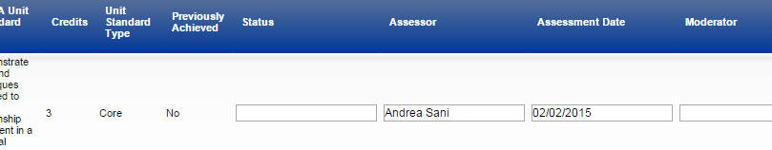

Click on Update Assessments.
The Status of the unit standard will appear as Competent.
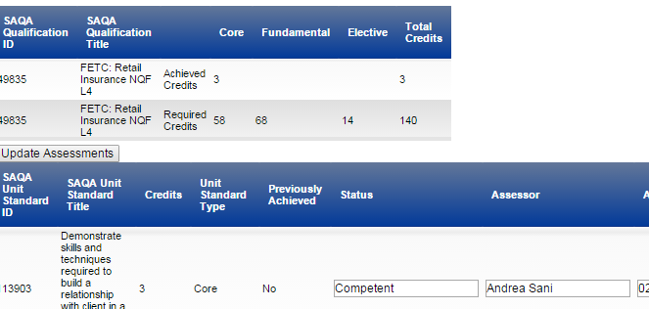

Once finished, click on Close
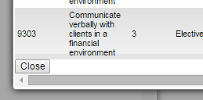

If you capture assessment against the incorrect Unit Standard you can delete this information by clicking on the cross:

Section 5: Provider Details
Introduction
Some of the data under Providers is captured by INSETA. It is the responsibility of the Provider to:
(a) check that the data captured by INSETA is correct and alert INSETA Certification unit of any errors
(b) Inform INSETA Certification unit of changes, such as if any contacts / users / assessors/ moderators leave their employ or change their details.

Step 1: Click on “ETQA”
The following screen will appear.
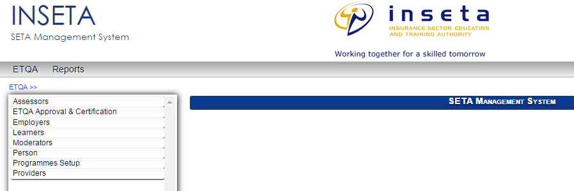
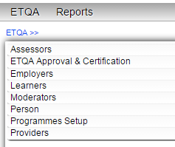
Dataset / Field | Description | Action | Pathway
Assessors | A list of the assessors, and their details, who are linked to the provider | View only | ETQA >> Assessors >> [Click on “Search” button]>> [Click on the magnifying glass icon to view an assessors details]
ETQA Approval & Certification | Learner Statements of Results can be downloaded. | Download and print
Employers | A list of the employers, employer contact details and the employers learners | View only | ETQA >> Employer >> [Click on “Search” button]>> [Click on the magnifying glass icon to view an employer details]
Learners | A list of learners linked to provider (view only)  To create / link a learner to a provider | Edit Learner details  Register a learner against a learning programme  Capture learner assessments | ETQA >> Learners >> [Click on “Search” button]>> [Click on the magnifying glass icon to view details]
Moderators | A list and details of provider’s moderators and their details (view only) | View only | ETQA >> Moderators >> [Click on “Search” button]>> [Click on the magnifying glass icon to view details]
Person | All learners, and their personal details, for all providers. | View, and  Create New Person | ETQA >> Personr >> [Click on “Search” button]>> [Click on the magnifying glass icon to view details and create new persons]
Programme Setup | Skills Programmes only  Provider can view the Skills programmes linked to it.  Provider can create a new Skills Programme. | View, and  Edit existing Skills programme(s), and  Create new Skills Programme(s) | ETQA >> Programme Setup >> [Click on “Search” button]>> [Click on the magnifying glass icon to view details]
Providers | Takes one to another screen with additional fields particular to the provider.

Click on Providers.
The following screen will appear.
Click on Search button.
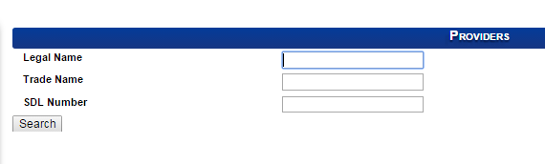
By clicking on “Search”, your provider name will appear.
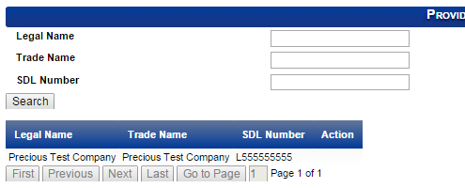
Click on your provider name and a magnifying glass icon will appear under the heading “Action”
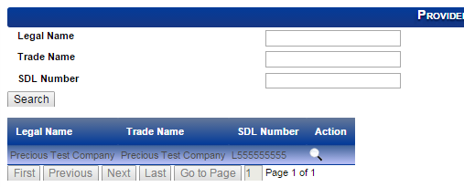
Click on the magnifying glass.
The following screen will appear. Note the fields on the left hand side. These fields contain information about you as a provider.
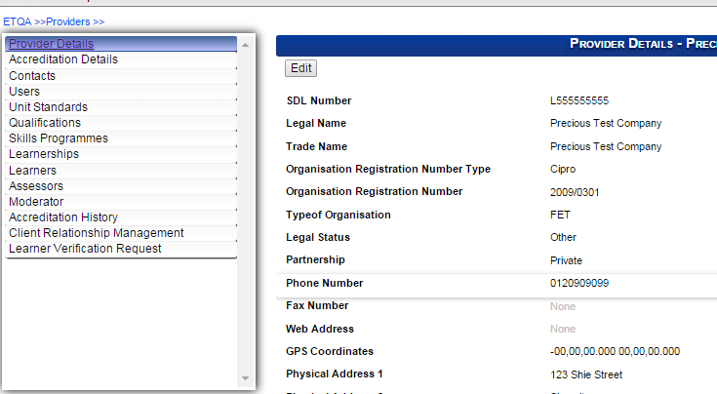
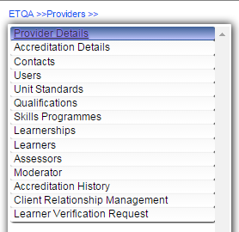

Field | Description | Action
Provider Details | Provider details: legal data, contact numbers, physical and postal address | View and Edit
Accreditation details | Accreditation type, accreditation number, accreditation start date; accreditation end date; SAQA code (Code SAQA has allocated to INSETA); SAQA Provider Code (Code SAQA allocates to each provider) | View
Contacts | The details of the senior staff / manager / owner of the provider | View
Users | The details of the staff who work on the Indicium database | Edit existing users.  Cannot add new users.
Unit Standards | A list of all the stand-alone unit standards the provider is accredited by INSETA to offer | View  These unit standards pull through automatically from the qualification(s) a provider is accredited to offer.
Qualifications | List of qualifications the provider is accredited to offer. | View
Skills Programmes | List of Skills Programmes the provider is accredited to offer. | View
Learnerships | List of Learnerships the provider is accredited to offer. | View
Learners | List of learners enrolled with the provider | View
Assessors | List of assessors employed by the provider
Moderator | List of moderators employed by the provider
Accreditation history | A history of the providers accreditation
Client Relationship Management | Electronic copies of Verification Reports, and other documentation pertaining to the provider | View and download.  NOTE: Provider must not upload documents into this field
 | Comment facility for INSETA
 | Email facility for INSETA QA to communicate to the provider
Learner Verification Request | UNDER CONSTRUCTION.

